Sections of the Forum:

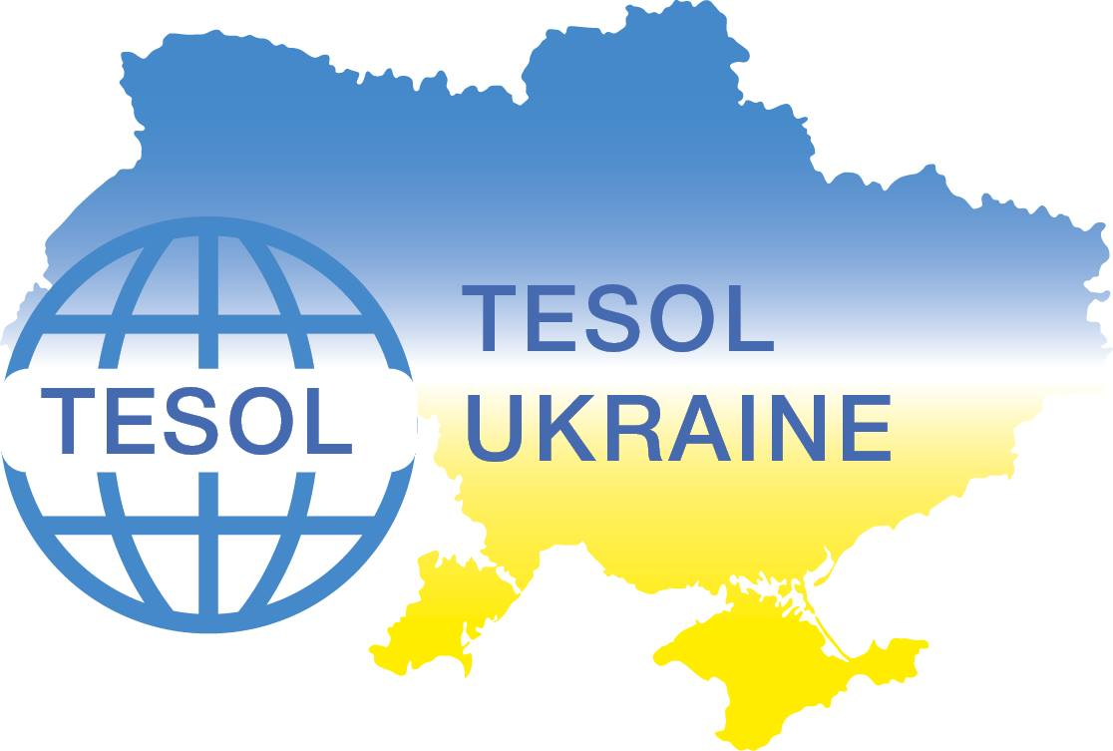



Ministry of Education and Science of Ukraine

O.M. Beketov National University of Urban Economy in Kharkiv

TESOL-Ukraine

X International Forum
“RESEARCH AND EDUCATION IN THE GLOBAL WORLD:

EUROINTEGRATION PROCESSES”
on-line

Conference date: May 10, 2024

- Contemporary Issues оf Democratic Society Development. Democracy Through Law.
- Innovative Trends оf Management аnd Tourism Business Development.
- Modern Developments of Economics аnd Financial Security.
- Latest Achievements іn Engineering, Ecology аnd Architecture.
- Innovative Methods оf Teaching English аt Higher аnd Secondary Educational Establishments.
Deadlines:
Paper submission: April 10, 2024

Conference Languages: English, German and French.
The participation in the conference is free
The general structure of the Paper (up to three pages):

PROJECT RISK MANAGEMENT PRACTICIES

OLGA OSIPENKO, student
IRINA V. POLIVNA, Associate Professor, PhD in Economics, Scientific Adviser
SVITLANA S. MOROZ, Senior Teacher, Language Adviser / SVITLANA S. MOROZ, Associate Professor, PhD in Philology, Language Adviser
O.M.Beketov National University of Urban Economy in Kharkiv

Understanding project management enables project teams to more effectively fulfill public service expectations…………………………………..
References
1. Halliday M. A. K. Language, Context, and Text Aspects of Language in a Social-semiotic Perspective / M. A. K. Halliday, R. Hasan. Oxford : Oxford Univ. Press, 2015. 320 р.
Requirements:
Times New Roman 14 pt, interline spacing 1.5.
Margins: Left – 30mm, upper/bottom -25mm, right – 20mm.
By April 10, 2024:

- Fill in Your Google Application Form https://docs.google.com/forms/d/1arCj4DHsd9bh8U1uNM-KY5rUFC5wH60LbHbvstgsXSA/edit
- e-mail your paper to beketovforum@gmail.com
Provide YOUR NAME, SURNAME AND SECTION NUMBER IN THE SUBJECT LINE OF YOUR EMAIL (e.g. Svitlana Osipenko _ 1). 1 – is the number of the section: Contemporary Issues оf Democratic Society Development. Democracy through Law.

- Send Your Paper (surname and section number are to be given in the name of the file attached) e.g. Osipenko_1

The papers of the participants should:
- reflect the topic of the presentation
- show significance and relevance for the certain special interest section and its audience
- be checked for spelling and grammar mistakes
- be received by the deadline (April 10, 2024)

The abstracts received after the deadline will not be considered for publishing.

The participants will receive the program and electronic version of the Book of Papers.

For more details contact the Organizing Committee at:
Kafedra313@gmail.com
Olena Ilienko (Head of the Foreign Languages and Translation Department)
+3 8 050 109 46 53 (Member of the Organizing Committee)

